TN SKILLS DEVELOPMENT – 2026

AUTO TICKET CLASSIFICATION USING FLOW DESIGNER

SUBMITTED BY

Name : | Register No
N. ANGEL | 24081231802912104
K. DHANA SELVI | 24081231802912111
V. PESILA | 24081231802912125

UNDER THE GUIDANCE OF
Mr. N. Bala Shanmugam, M.Sc., M. Phil., M. tech.,


DEPARTMENT OF COMPUTER SCIENCE WITH DATA SCIENCE SRI PARAMAKALYANI COLLEGE
(AFFILIATED TO MANONMANIAM SUNDARANAR UNIVERSITY TIRUNELVELI)

NOVEMBER – 2026

TN SKILLS DEVELOPMENT – 2026



PROJECT TEAM:
N. ANGEL | 24081231802912104
K. DHANA SELVI | 24081231802912111
V. PESILA | 24081231802912125

Department: Computer science with Data science
Course: B.Sc. Computer science with Data science
Project Title: Auto Ticket Classification Using Flow Designer



SRI PARAMAKALYANI COLLEGE ALWARKURICHI – 627 412
CERTIFICATE

This is to certify that the project report entitled “Auto Ticket Classification Using Flow Designer” submitted by ANGEL N (Register No: 24081231802912104), DHANA SELVI K (Register No:24081231802912111), and PESILA V (Register No: 24081231802912125), Department of Computer Science with Data Science, Sri Paramakalyani College, Alwarkurichi, Tenkasi – 627412, has been carried out in partial fulfilment of the requirements for the award of the degree of BACHELOR OF SCIENCE IN COMPUTER SCIENCE WITH DATA SCIENCE during the academic year 2026–2027.

STAFF IN-CHARGE HEAD OF THE DEPARTMENT

Submitted for the University Examination held on: .

EXTERNAL EXAMINER

CONTENTS

S.No | Contents | Page No
1 | Abstract | 1
2 | Introduction  - Problem Statement  - Objectives  - Scope  - Workflow | 1
3 | Requirements  - Functional Requirements  - Non-Functional Requirements | 3
4 | System Design  - System Overview  - Data Fields | 6
5 | Implementation  - Ticket Processing  - Keyword-Based Classification  - Flow Designer Configuration  - Email Notification  - Data Validation and Configuration Management | 7
6 | Reports and Dashboard  - Tickets by Category  - Tickets by State  - IT Support Ticket List Report  - IT Support Analytics Dashboard | 10
7 | Testing and Validation | 11
8 | Results and Discussion | 12
9 | Limitations and Future Enhancements  - Limitations  - Future Enhancements | 13
10 | Conclusion | 15
11 | References | 16
12 | Appendix A – Implementation Steps | 16

1.ABSTRACT
The Auto Ticket Classification using Flow Designer project aims to automate the classification of IT support tickets in a school environment using the ServiceNow platform. The school IT helpdesk receives numerous incident requests from students and teachers related to network connectivity, hardware failures, account access issues, and computer performance problems. Manually reviewing and categorizing these requests requires considerable time and effort, which may lead to incorrect classification and delays in resolving issues.
The proposed system uses ServiceNow Flow Designer to automatically classify tickets based on keywords in the short description provided by the user. A custom table is created to store ticket information, including caller details, category, subcategory, short description, description, state, assigned group, and assigned user. The system identifies keywords such as Wi-Fi, projector, password, and slow computer to assign the appropriate category and subcategory automatically. Dependent choice fields are configured to ensure that the available subcategories correspond to their respective categories.

2. INTRODUCTION
The Auto Ticket Classification using Flow Designer project is designed to automate the classification of IT support tickets in educational institutions using the ServiceNow platform. The system identifies common technical issues based on keywords in the short description and automatically assigns the appropriate category and subcategory. It also maintains ticket information in a custom table and sends email notifications to callers after ticket creation. By using ServiceNow Flow Designer, the project reduces manual effort, improves classification consistency, and provides an efficient solution for managing school IT helpdesk requests without complex programming or machine learning techniques.

2.1 PROBLEM STATEMENT
In schools and educational institutions, the IT helpdesk receives various technical support requests from students and teachers, including Wi-Fi connectivity problems, projector failures, forgotten passwords, and slow computer performance. Traditionally, IT staff manually review each ticket, identify the issue, and assign the appropriate category and subcategory. This process consumes time and effort, particularly when the number of support requests increases.
Manual ticket classification can result in incorrect categorization, inconsistent data entry, and delays in handling support requests. To overcome these problems, the proposed system uses ServiceNow Flow Designer to analyze keywords in the short description and automatically classify tickets. It also provides dependent choice fields and automated email notifications to improve data accuracy and communication between the helpdesk and callers.

2.2 OBJECTIVES
The main objectives of the Auto Ticket Classification using Flow Designer project are:
1. Automated Ticket Classification: To classify IT support tickets automatically based on predefined keywords in the short description.
2. Reduce Manual Effort: To minimize the time and effort required by IT staff to categorize support requests.
3. Data Standardization: To store ticket information in a structured format using a custom table in ServiceNow.
4. Email Notification: To send an automated confirmation email to the caller after ticket creation.
5. No-Code Automation: To implement the classification process using ServiceNow Flow Designer without complex programming or machine learning.

2.3 SCOPE
The scope of this project includes creating a custom table in ServiceNow to store IT support ticket information and configuring fields such as caller, ticket number, category, subcategory, short description, description, state, assigned group, and assigned user. It also includes configuring dependent choice fields to maintain the relationship between categories and their corresponding subcategories.
The system uses Flow Designer to classify newly created tickets based on predefined keywords and update the appropriate fields automatically. It also sends email notifications to callers and supports testing, validation, and Update Set management. The project focuses on keyword-based classification and does not include artificial intelligence, machine learning, or advanced natural language processing.

2.5WORKFLOW

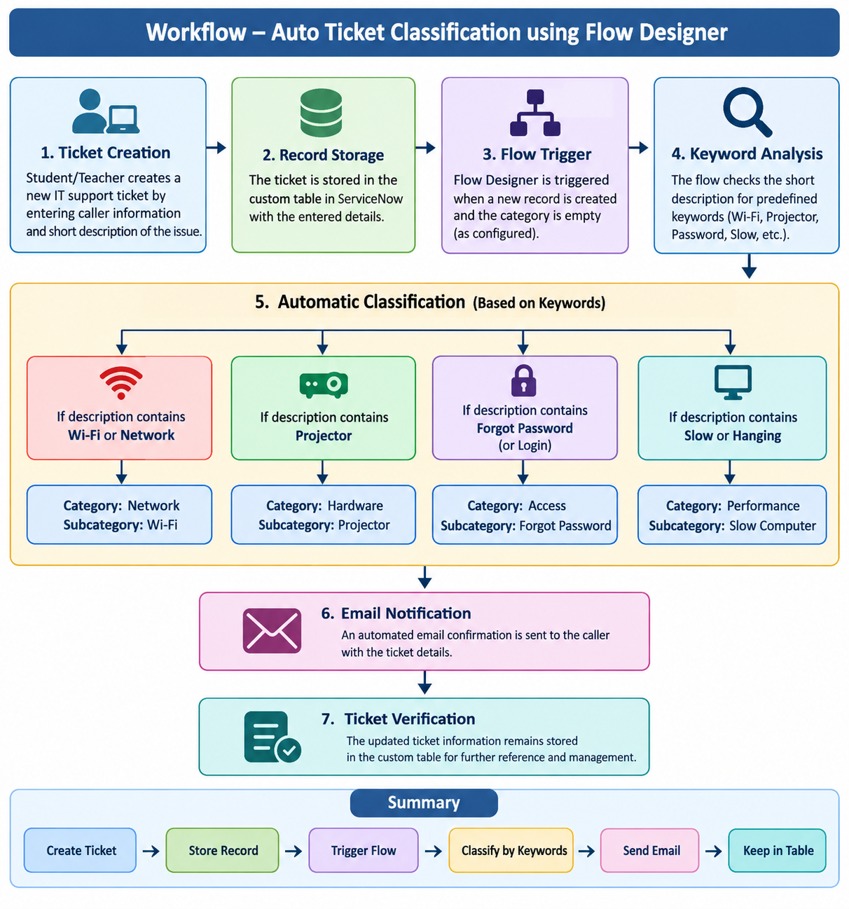

3.REQUIREMENTS
The requirements of the Auto Ticket Classification using Flow Designer project define the essential features and system qualities needed to automate IT support ticket management. The system is developed using the ServiceNow platform to classify tickets based on predefined keywords, maintain structured ticket records, and send automated email notifications. Identifying these requirements helps ensure that the system meets the needs of the school IT helpdesk and operates efficiently.

3.1 FUNCTIONAL REQUIREMENTS

Functional requirements describe the operations performed by the Auto Ticket Classification using Flow Designer system.
- Ticket Creation: The system must allow users to create IT support tickets by entering caller details and the short description.
- Automatic Ticket Number: The system must generate a unique ticket number for each new record.
- Ticket Storage: The system must store ticket information in the custom Incident Workflow table.
- Keyword Identification: The system must identify predefined keywords in the short description.
- Automatic Classification: The system must assign the appropriate category and subcategory based on the identified keywords.
- Category Management: The system must support Network, Hardware, Access, and Performance categories.
- Email Notification: The system must send a ticket confirmation email to the caller.
- Ticket Verification: The system must allow authorized users to view and verify ticket details.

3.2 NON-FUNCTIONAL REQUIREMENTS
Non-functional requirements describe the quality, reliability, security, and maintainability of the system.
- Usability: The system should provide a simple and user-friendly interface for creating and managing tickets.
- Performance: The classification flow should process new tickets efficiently.
- Reliability: The system should perform classification and notification actions consistently when the configured conditions are satisfied.
- Security: Access to ticket records should be restricted according to appropriate user roles and permissions.
- Maintainability: Classification rules should be easy to modify and update using Flow Designer.
- Scalability: The system should support adding new categories, subcategories, and classification conditions.
- Compatibility: The system should operate within a properly configured ServiceNow instance.

4. SYSTEM DESIGN
System design describes the overall structure, components, and data organization of the Auto Ticket Classification using Flow Designer project. The system is developed on the ServiceNow platform to automate IT support ticket classification, maintain structured ticket records, and send email notifications. The design combines a custom table, predefined choice fields, Flow Designer automation, and email notification functionality to provide an efficient ticket management solution.

4.1 SYSTEM OVERVIEW

The Auto Ticket Classification using Flow Designer system is developed on the ServiceNow platform to automate the classification of IT support tickets in a school environment. It uses Flow Designer to analyze predefined keywords in the short description and automatically assign the appropriate category and subcategory. The system reduces manual effort and improves consistency in ticket management.
The system includes a custom Incident Workflow table, dependent choice fields, keyword-based classification rules, and automated email notifications. When a new ticket is created, the configured flow checks the short description, updates the classification fields, and sends a confirmation email to the caller. The ticket information is stored in the table for future reference and management.

4.2 DATA FIELDS
The custom Incident Workflow table stores the information required to create, classify, and manage IT support tickets.
S. No. | Field Name | Data Type | Purpose
1 | Number | Auto Number | Generates a unique ticket number.
2 | Caller | Reference (sys_user) | Identifies the user who reports the issue.
3 | Category | Choice | Stores the main issue category.
4 | Subcategory | Choice | Stores the specific type of issue.
5 | Short Description | String | Provides a brief summary of the issue.
6 | Description | String | Stores additional details about the issue.
7 | State | Choice | Indicates the current status of the ticket.
8 | Assigned Group | Reference (sys_user_group) | Identifies the support group responsible for the ticket.
9 | Assigned To | Reference (sys_user) | Identifies the user assigned to handle the ticket.

Category and Subcategory Values
Category | Subcategory
Network | Wi-Fi
Hardware | Projector
Access | Forgot Password
Performance | Slow Computer

5. IMPLEMENTATION
5.1 TICKET PROCESSING
Ticket processing begins when a student or teacher creates a new IT support ticket by entering the caller information and short description of the issue. The ticket is stored in the custom Incident Workflow table with an automatically generated ticket number. The table maintains the ticket details in a structured format, including category, subcategory, description, state, assigned group, and assigned user.
After a new record is created, Flow Designer is triggered when the configured conditions are satisfied. The flow examines the short description to identify keywords associated with common IT issues. Based on the matching condition, the system updates the category and subcategory fields automatically, reducing the need for manual classification.

5.2 KEYWORD-BASED CLASSIFICATION

Keyword-based classification is the main functionality of the system. ServiceNow Flow Designer uses conditional logic to examine the short description and identify predefined keywords. The configured conditions recognize common issues related to Wi-Fi connectivity, projector failures, forgotten passwords, and slow computer performance.

When a matching keyword is identified, the flow assigns the corresponding category and subcategory. For example, Wi-Fi-related issues are classified under Network, projector issues under Hardware, password-related issues under Access, and slow computer issues under Performance. This approach provides consistent ticket classification using predefined rules without requiring machine learning or complex programming.

5.3 FLOW DESIGNER CONFIGURATION

Flow Designer is configured to automate the ticket classification process when a new record is created in the Incident Workflow table. The trigger is set to Record Created, with the condition that the Category field is empty. Conditional branches are then created to check the short description for relevant keywords and execute the appropriate Update Record action.

Each Update Record action assigns the corresponding category and subcategory values. For example, a ticket containing the keyword "Projector" is updated with Category = Hardware and Subcategory = Projector. After configuring the classification conditions and actions, the flow is activated and tested using different ticket descriptions to verify the expected results.
5.4 EMAIL NOTIFICATION
The email notification component informs the caller that their IT support request has been submitted. A Send Email action is configured in Flow Designer to send a confirmation message to the caller's email address. The email includes a suitable subject and message confirming the ticket submission.
This functionality improves communication between the helpdesk and the caller by providing an automatic acknowledgement after ticket creation. The notification process is tested by creating sample tickets and checking the generated email records in the ServiceNow email logs.
5.5 DATA VALIDATION AND CONFIGURATION MANAGEMENT
Data validation ensures that ticket information is stored correctly and that the classification process produces the expected results. Testing includes checking automatic ticket number generation, verifying category and subcategory assignments, confirming reference-field values, and checking email notification functionality. Sample descriptions such as "WiFi not working in library" and "Projector not turning on" are used to verify the classification rules.

6. REPORTS AND DASHBOARD

The Reports and Dashboard section provides an overview of the IT support tickets created and classified by the system. It helps IT staff review ticket records, understand the distribution of reported issues, and monitor ticket information. Reports can be developed using available ServiceNow reporting features based on the data stored in the Incident Workflow table.

6.1 TICKETS BY CATEGORY

This report displays the number of IT support tickets under each category, including Network, Hardware, Access, and Performance. It helps the IT helpdesk identify the most frequently reported types of technical issues and understand the distribution of support requests.

6.2 TICKETS BY STATE

This report presents the distribution of tickets according to their current state, such as New, In Progress, On Hold, Resolved, and Closed. It helps authorized users monitor ticket status and identify requests that may require further attention.

6.3 IT SUPPORT TICKET LIST REPORT

This report displays the details of individual tickets stored in the Incident Workflow table. It includes the ticket number, caller, category, subcategory, short description, state, assigned group, and assigned user. The report helps IT staff review ticket information and track support requests.

6.4 IT SUPPORT ANALYTICS DASHBOARD

The IT Support Analytics Dashboard provides a visual summary of ticket information through charts, reports, and data visualizations. It can display ticket counts by category, ticket status distribution, and frequently reported issues. This dashboard can help the helpdesk understand support request patterns and make informed decisions about managing IT services.

7. TESTING AND VALIDATION
S. No. | Test Case | Input / Action | Expected Result | Status
1 | Ticket Creation | Enter caller and short description | Ticket record is created successfully | To be verified
2 | Auto Number Generation | Create a new ticket | Unique ticket number is generated | To be verified
3 | Wi-Fi Classification | WiFi not working in library | Network → Wi-Fi | To be verified
4 | Projector Classification | Projector not turning on | Hardware → Projector | To be verified
5 | Password Classification | Forgot password | Access → Forgot Password | To be verified
6 | Performance Classification | Computer is slow | Performance → Slow Computer | To be verified
7 | Dependent Choice Validation | Select a category | Corresponding subcategory options are displayed | To be verified
8 | Email Notification | Create a new ticket | Confirmation email action executes as configured | To be verified
9 | Data Storage | Open the saved ticket | Ticket details are stored correctly | To be verified
10 | Reference Field Validation | Select caller and assigned group | Reference fields resolve to the appropriate records | To be verified

8. RESULTS AND DISCUSSION
The Auto Ticket Classification using Flow Designer project provides a simple method for automating the classification of school IT support tickets in ServiceNow. When a new ticket is created in the Incident Workflow table, the Flow Designer checks the short description for configured keywords and updates the corresponding category and subcategory. For example, a ticket containing “WiFi not working in library” is expected to be classified as Network and Wi-Fi, while “Projector not turning on” is expected to be classified as Hardware and Projector. Similarly, “Forgot password” is expected to be classified as Access and Forgot Password, and “Computer is slow” as Performance and Slow Computer. The system also supports automatic ticket number generation and is configured to send a confirmation email to the caller.
The results demonstrate how keyword-based classification can reduce manual effort and improve consistency in handling common school IT issues. ServiceNow Flow Designer allows these tasks to be configured using conditions and record-update actions without requiring complex programming or AI/ML techniques. However, the accuracy of classification depends on the keywords and conditions configured in the flow. If a ticket does not contain a recognized keyword, manual verification may be necessary. The email notification feature also depends on the correct configuration of the email action and system settings. Overall, the project provides a practical foundation for improving school IT helpdesk operations, with opportunities for future enhancements such as additional keywords, automatic ticket assignment, and report generation. Actual results should be confirmed through testing in the ServiceNow instance.

9. LIMITATIONS AND FUTURE ENHANCEMENTS
The Auto Ticket Classification using Flow Designer system simplifies the process of classifying school IT support tickets through keyword-based automation. However, the system has certain limitations related to keyword recognition, classification coverage, and automation capabilities. These limitations provide opportunities for future improvements to make the system more flexible, efficient, and suitable for handling a larger number of support requests.
9.1 LIMITATIONS
The system has the following limitations:
1. Keyword Dependency: Classification depends on predefined keywords in the short description. Unrecognized words may prevent the ticket from being classified correctly.
2. Limited Categories: The system currently supports four categories: Network, Hardware, Access, and Performance.
3. No AI or Machine Learning: The system uses predefined conditions in Flow Designer rather than AI or machine learning to understand ticket descriptions.
4. Manual Verification: Tickets that do not match the configured conditions may require manual review and classification.
5. Email Configuration: Confirmation emails depend on the correct configuration of the Send Email action and ServiceNow email settings.
6. Limited Automation: The current implementation focuses on ticket classification and confirmation emails. Automatic assignment to support groups and advanced escalation are not included.

9.2 FUTURE ENHANCEMENTS
The Auto Ticket Classification using Flow Designer system can be enhanced in the future to improve its efficiency, accuracy, and usability. The following improvements can be implemented:
1. Additional Keywords: Include more keywords and variations to classify a wider range of school IT issues accurately.
2. Automatic Ticket Assignment: Automatically assign tickets to the appropriate IT support groups based on the identified category.
3. Priority Management: Set ticket priorities according to the urgency and impact of the reported issues.
4. AI-Based Classification: Integrate AI or machine learning techniques to identify and classify ticket descriptions more intelligently.
5. SLA Monitoring: Implement Service Level Agreements (SLAs) to monitor response and resolution times.
6. Reports and Dashboards: Develop reports and dashboards to display ticket counts, categories, states, and resolution performance.
7. Enhanced Email Notifications: Send notifications to users when their tickets are assigned, updated, resolved, or closed.
8. Ticket Tracking: Provide users with an improved interface to track the status and progress of their support requests.

10. CONCLUSION

The project “Auto Ticket Classification using Flow Designer” successfully demonstrates a simple approach to automating school IT helpdesk ticket classification using ServiceNow. The system uses Flow Designer to identify predefined keywords in ticket short descriptions and update the corresponding categories and subcategories, including Network, Hardware, Access, and Performance. It also supports automatic ticket number generation and is configured to send confirmation emails to users after ticket submission.

This project reduces the need for manual ticket classification and helps improve the consistency of handling common IT support requests. By using ServiceNow's no-code Flow Designer features, the system can be configured and maintained without complex programming or AI and machine learning techniques. Although the current implementation has limitations, such as dependency on predefined keywords, it provides a foundation for further improvements. Future enhancements, including automatic ticket assignment, priority management, SLA monitoring, and report generation, can make the system more efficient and reliable. Overall, the project demonstrates how workflow automation can simplify school IT support operations and improve ticket management.

11. REFERENCES
1. ServiceNow, Flow Designer Documentation. https://www.servicenow.com/docs/
2. ServiceNow, ServiceNow Developer Portal. https://developer.servicenow.com/
3. ServiceNow, Email Notifications Documentation. https://www.servicenow.com/docs/
4. ServiceNow, Update Sets Documentation. https://www.servicenow.com/docs/
5. ServiceNow, ServiceNow Community. https://www.servicenow.com/community/

APPENDIX A – IMPLEMENTATION STEPS
  - Log in to ServiceNow: Access the ServiceNow instance using valid login credentials.
  - Create the Custom Table: Create a table named Incident Workflow to store school IT support ticket details.
  - Configure Table Fields: Add fields such as Number, Caller, Category, Subcategory, Short Description, Description, State, Assigned Group, and Assigned to.
  - Configure Categories and Subcategories: Create the required choices for Network, Hardware, Access, and Performance, along with their corresponding subcategories.
  - Configure Dependent Choices: Set the Subcategory field to depend on the selected Category so that relevant options are displayed.
  - Create a Flow: Open Flow Designer and create a flow named Auto Classify School IT Tickets.
  - Configure the Trigger: Set the trigger to Record Created for the Incident Workflow table and configure the condition that Category is empty.
  - Add Classification Conditions: Configure conditions to check keywords in the Short Description, such as Wi-Fi, Projector, Forgot Password, and Slow Computer.
  - Update the Ticket Record: Add Update Record actions to set the appropriate category and subcategory when a configured keyword matches.
  - Configure Email Notification: Add a Send Email action to send a ticket confirmation message to the caller.
  - Test the Flow: Create sample tickets and verify whether the category and subcategory are updated correctly. Check the email logs to verify the notification action.
  - Create and Export an Update Set: Create an Update Set, mark it complete after configuration, and export it as an XML file for transfer or backup.

